Non HCAD House bills
Document Types:
The non-HCAD House bill evidence PDF contains Card, Equity, and Sales Pages. Other than these pages are photos, sales ratio pages, maps, market study report and other supporting documents.
- Non-HCAD House bills will be indexed as House bill 201 Evidence in paperwise document type
- Other Supportive documents for the hearing will be indexed as County Generic Packets
Sources for House bills
- Email Box (salesprocessing@poconnor.com & salesprocessing_pfba@poconnor.com)
- OCAFTP – FTP logins provided in Protest letters & CCL
- County Portals Downloads
- Cluster location (S Drive)

Sales details extraction process: -
All the sales information is extracted from the house bills. At some time sales data is provided in image format as well, which is manually we must scrape all the sales from the non-Hcad House bills, whether it is an image or PDF format.
The various sources of sales will be handled in our Non HCAD House Bill process as follows:

Sources of Sales
- House bills Evidence
- Listing Website
- ATTOM
- EDDB
- ORR
- Listing Website-General Search
- ORR- Open record request from county
- ATTOM/EDDB-Database

Housebills Evidence
Email Box
- We have created an internal mailbox for segregating the Housebills related emails.
- The client/Property Owners/County can send Housebills evidence directly to us.
- We can process the received emails and send responses directly to the county, clients/Property owners from the email box.
Email Distro: salesprocessing@poconnor.com
Password: Sales@pfba
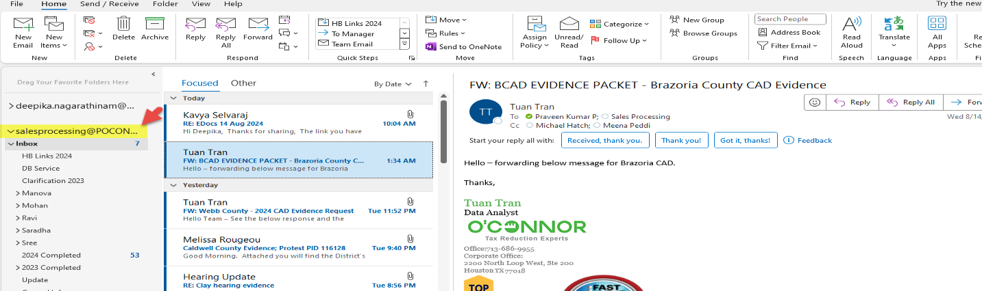

OCAFTP
OCAFTP site was created by the Houston team to upload the Housebill evidence.
Link: https://oconnor.files.com/files/
Username: Ocaftp
Password: Ind1go325??

A county wise folder is created, and HB related documents will be uploaded by the Oconnor Agent/ County Agents.
We need to login to the FTP site and download the documents.
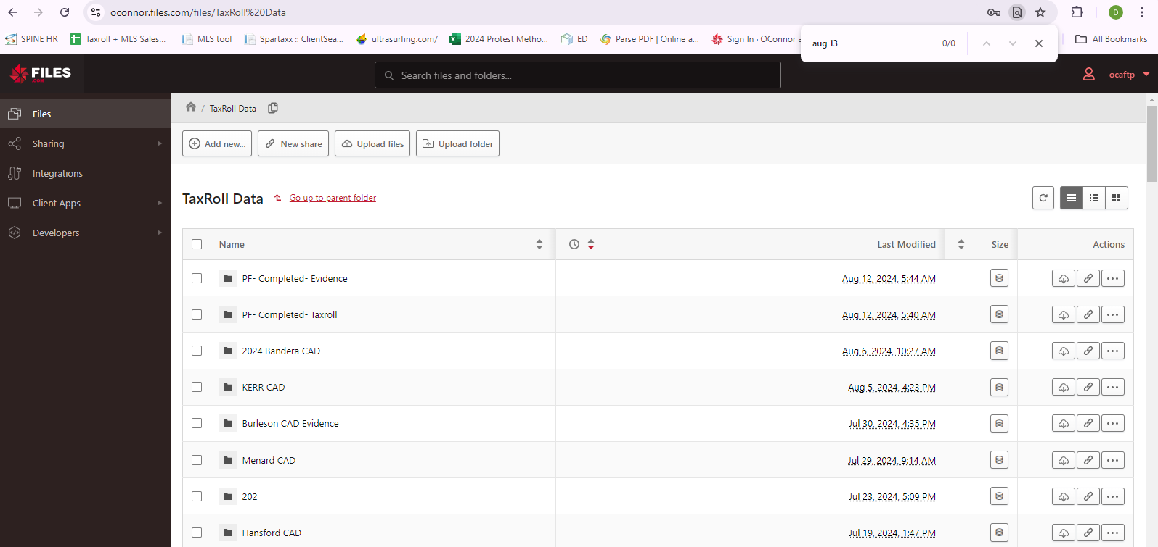

County Portals
We have login portal links for a few counties.
HB Download Links.xlsx (sharepoint.com)
We need to login into the site using the provided login credentials and download the House bills.
Here, attached the few sample screenshots of login portals
For 17 counties we have the below format,
Aransas | Hidalgo
Brazoria | Henderson
Burnet | MCAD
Brazos | Kaufman
Comal | Grayson
Denton | Victoria
Fbcad | Polk
Galveston | Taylor
Wichita

Ex: Denton Agent Portal
Click I am an agent Enter login Details and follow the instructions in the snap shot.

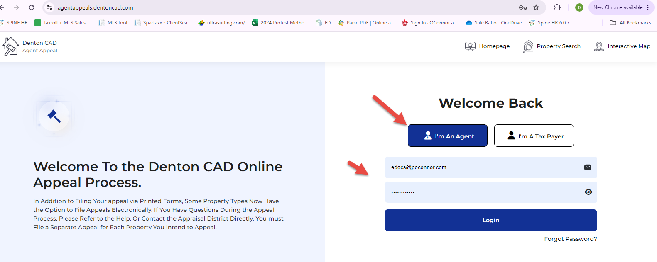
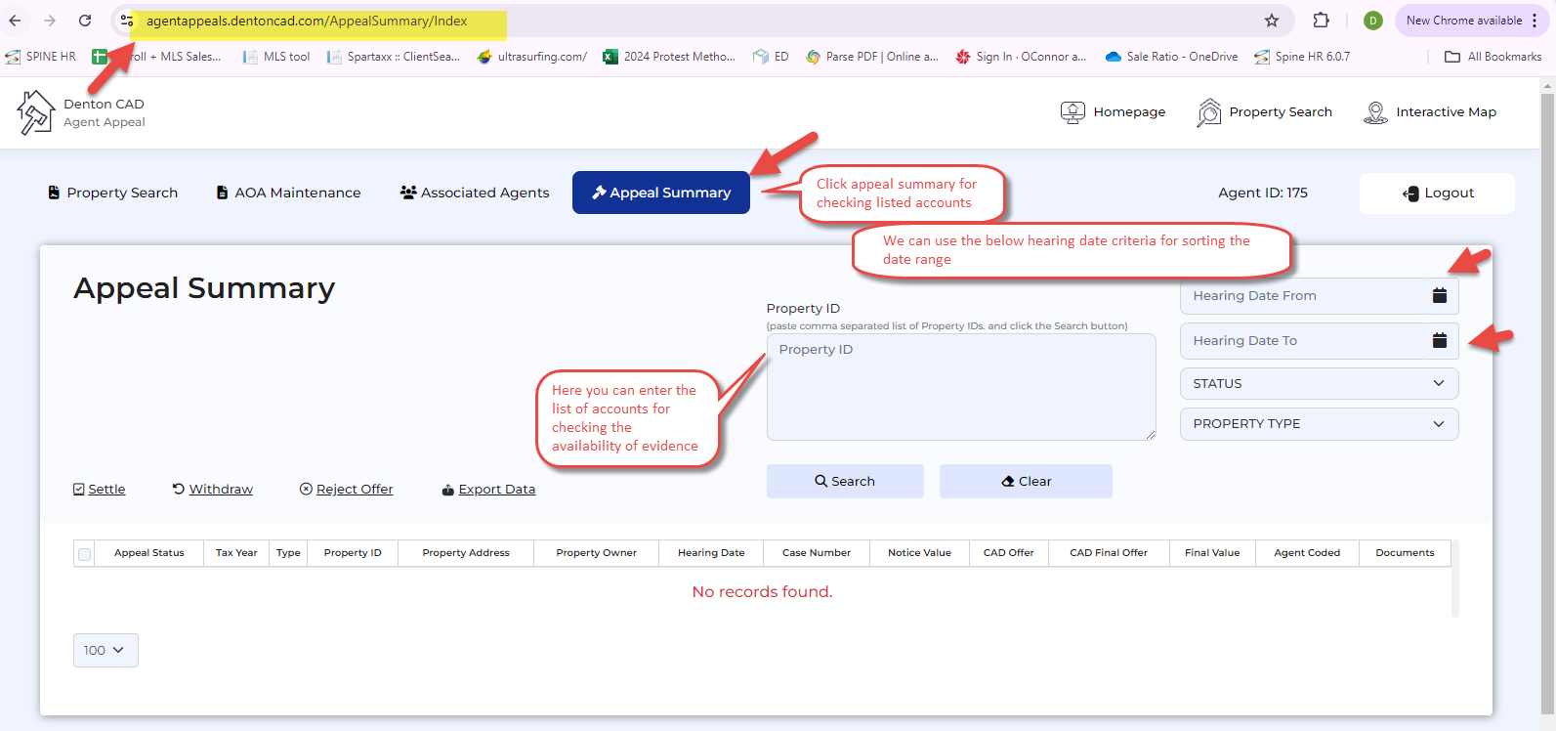
I have provided one more example below
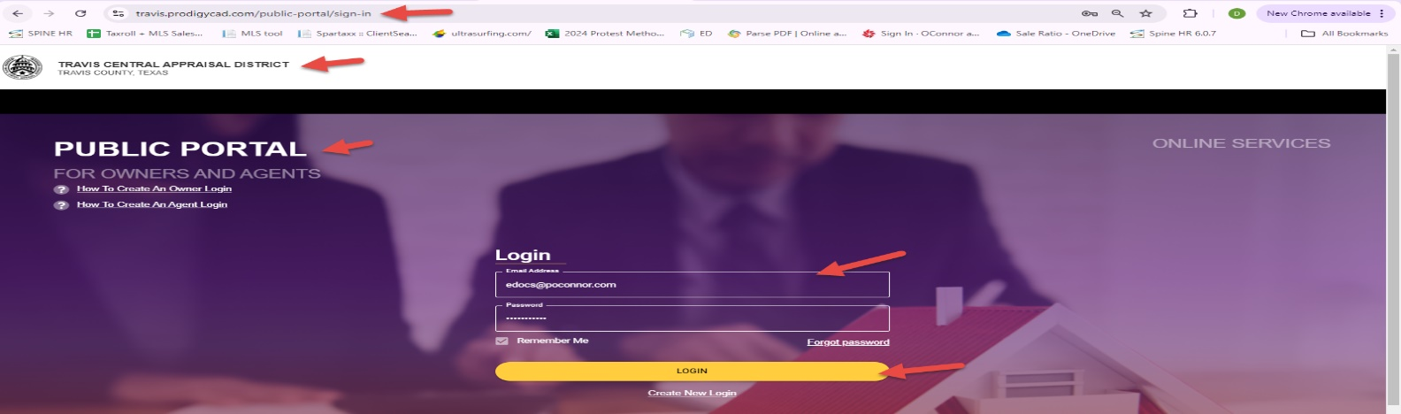
Travis county

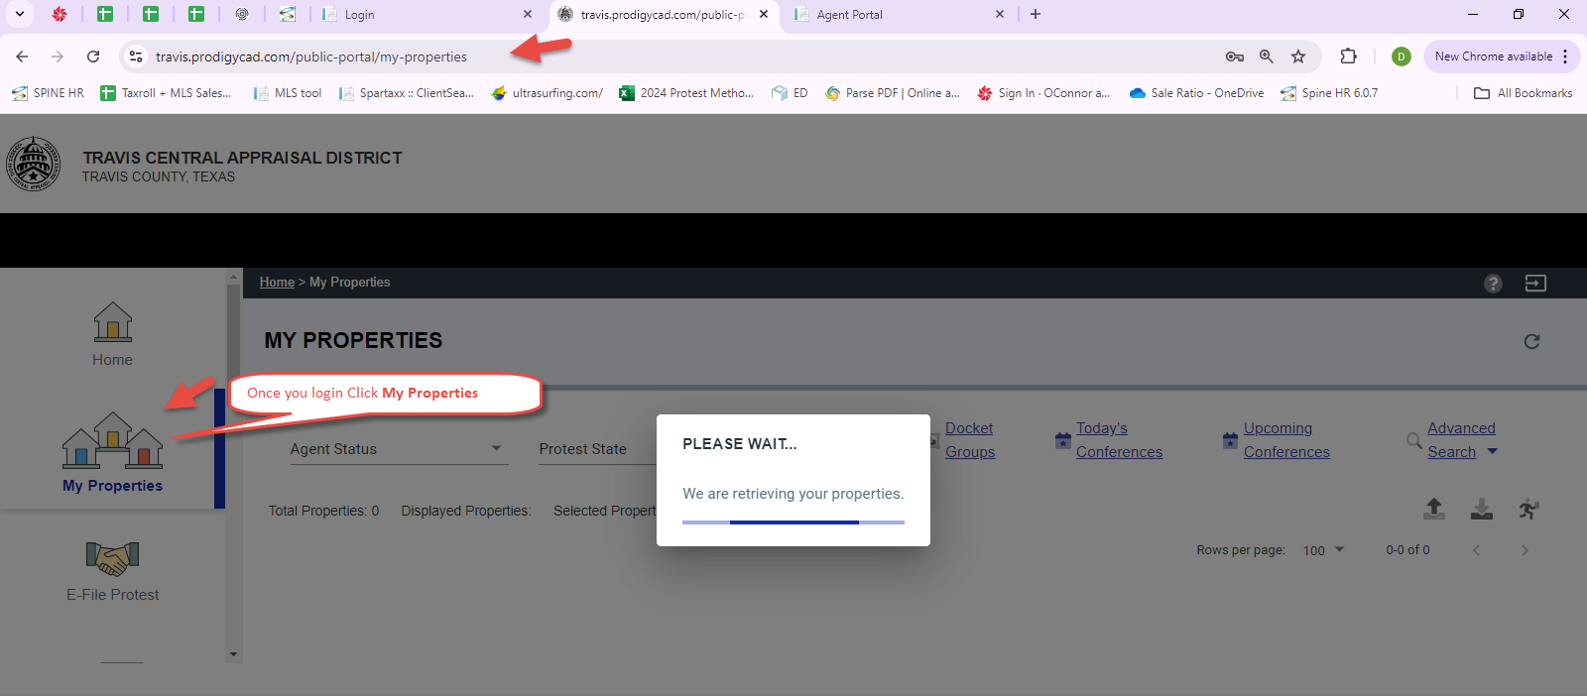
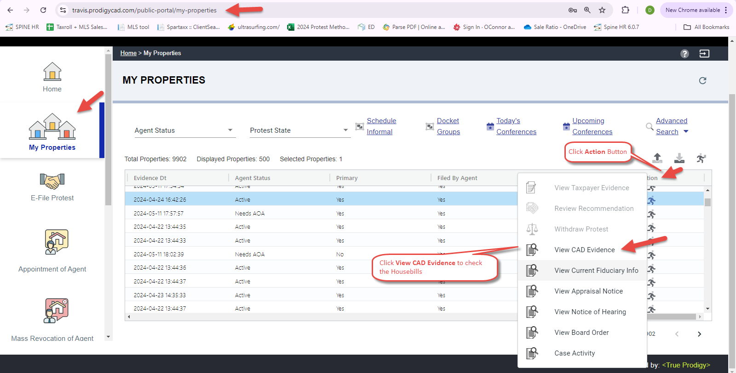
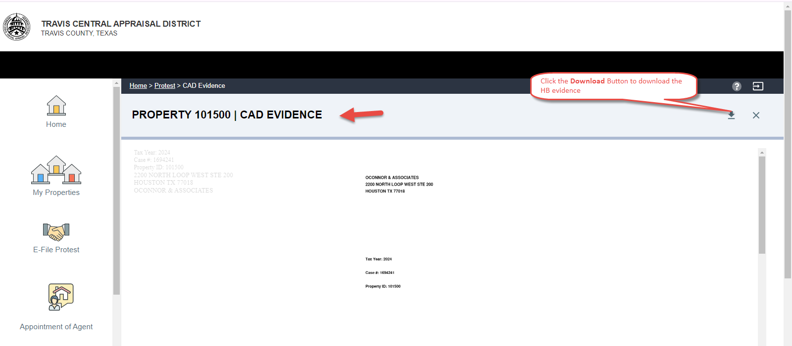
Note: Rest of the counties, we need to login and visit the online portal links for downloading the evidence.

Cluster Folder
This folder was created by the Houston Team for pasting Housebills or emails with huge data.
\\cluster01\SharedFiles\Property Tax\CountyData
Once after the Downloading the Housebills using the above procedures, we need to follow the below procedure,
- Housebills may be received in various ways/format, we need to split & combine the documents in Card, Equity and Sales page wise for the subject property.
- Housebill documents should be in PDF format.
For Merging, Splitting, combining, we will use Online tools, Macros or PDF extractor tools.
Sales Extraction Process: -
PDF Extractor Tools
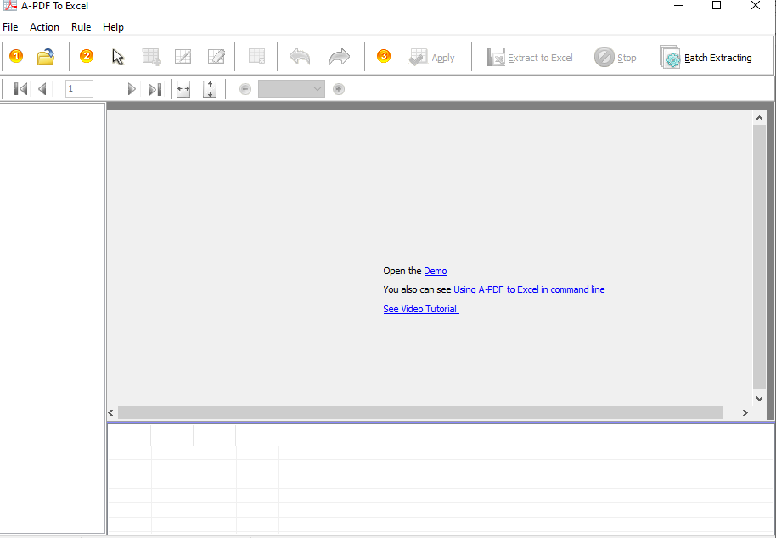
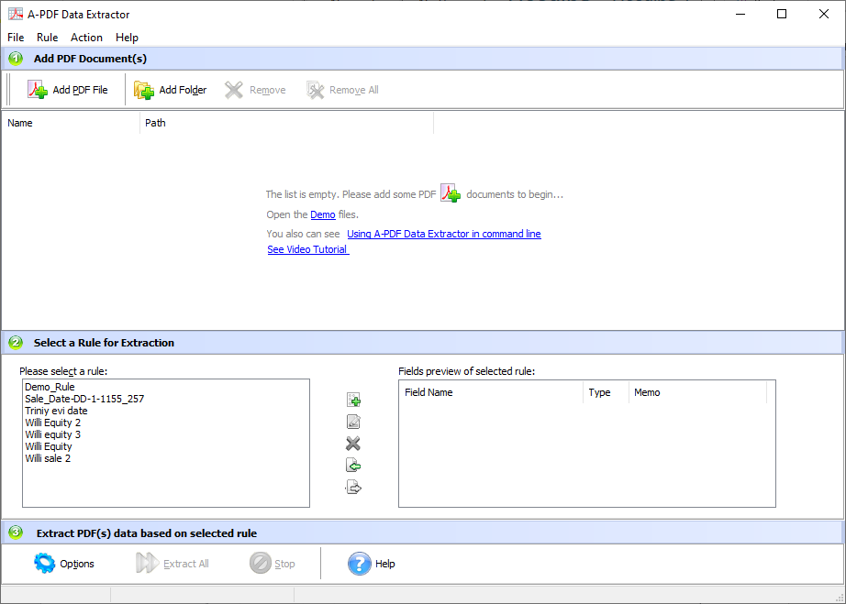
Followed by the above Procedures,
Once the HB document is formatted and saved as PDF, it is ready for indexing, we need to Index the document into Paperwise Application.
Paperwise Application is available in both Houston and Indian servers.
Note: The Housebill documents can be received as whole package or partial.
For Ex: We may receive only card/Sales/equity/maps pages etc.
However, we could index the document if the documents received partially.
Send To Application
If the Housebill document is indexed manually, we need to use the “Send To” application for bringing PDFs into Paperwise, respectively.
- We need to right click on the PDF to be indexed and Click “Send To”
- We can select multiple documents and can send it via “Send To” application.
- The Housebill document will be available in Send to application, there we can preset our preferences, Like the followings:
File Cabinet=Property Tax
Doc Type: Housebill 201 Evidence
Tax Year : 2024 (Given in the HB document)
Batchcode: Format is HB-mmddyy-empid (HB-070124-2463)
Status: NEW
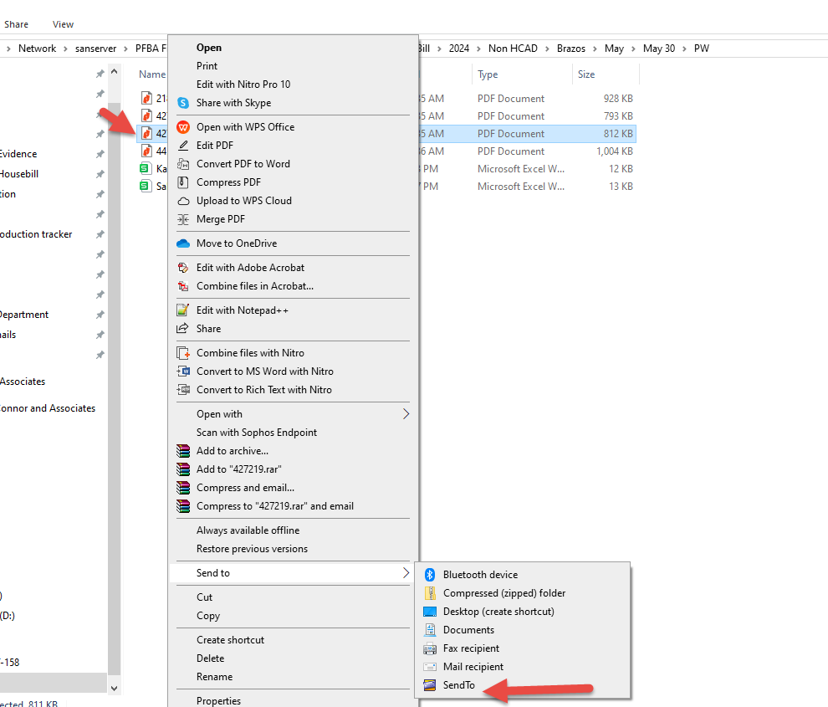
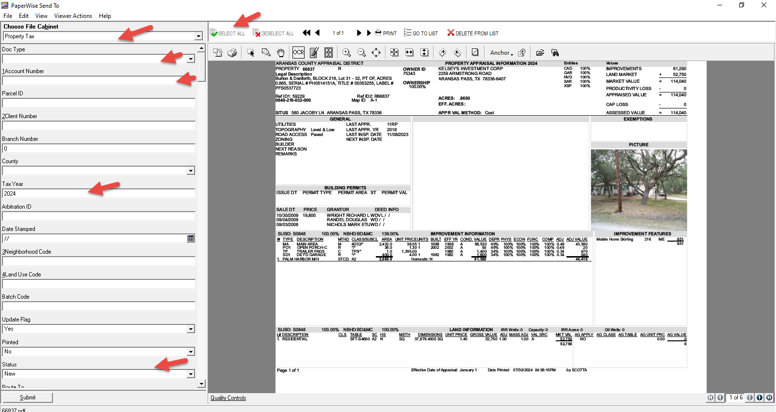

Paperwise Application
Housebills should be indexed either manually or using spartaxx automation.
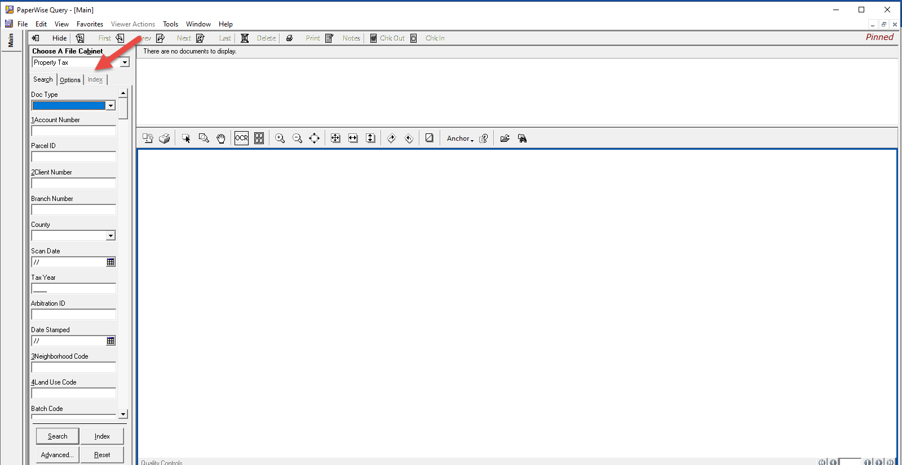
Procedure for Manual Indexing
Once the PDF’s are indexed into Paperwise, the below steps to be followed
- Click “Chck Out" button and enter the account number from PDF into the account number field available in the left pane.
- Update the account number and click Enter the county and client number field will be auto indexed from spartaxx.
- If the account has two client numbers, it will prompt us with a dialog box. There we can choose the exact client number (active or Inactive).
- Select the status as “Complete” and click Enter. It will show a dialog box as update the current document Click “YES”.
- The document will be available in our paperwise servers.
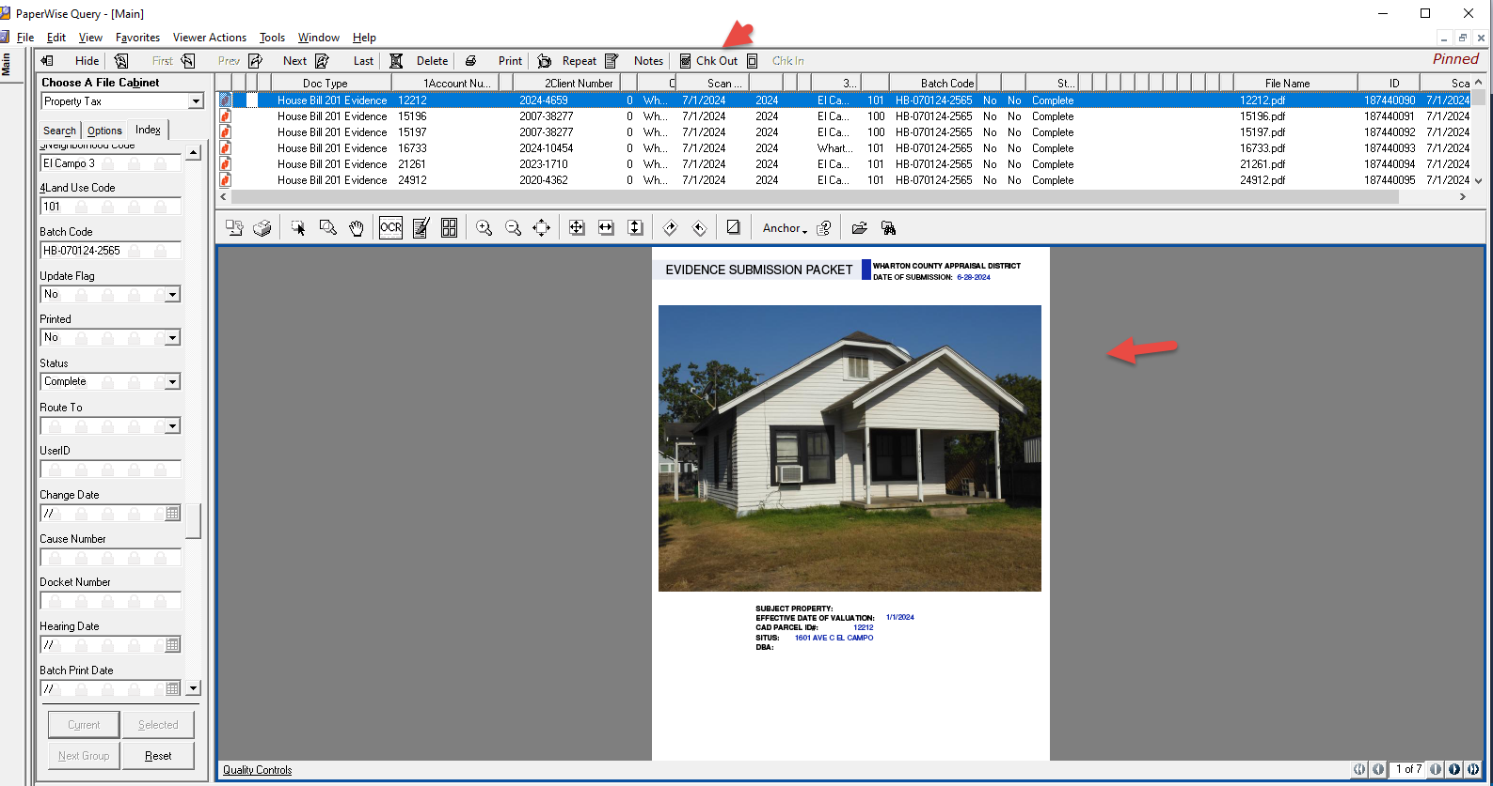
Procedure for Spartaxx Automation Indexing
We can index the bulk Housebills into Paperwise using Spartaxx automation Option.
Login SpartaxxAutomation Hearing Details - PW Automation
The User can find a template for uploading. We can download the template and have the data filled in it.
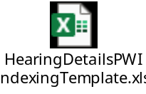
Select the files to be uploaded File Upload
The files will be listed out in Spartaxx then Click Proceed.

The user will wait till the “Files will be successfully Uploaded” pop up.

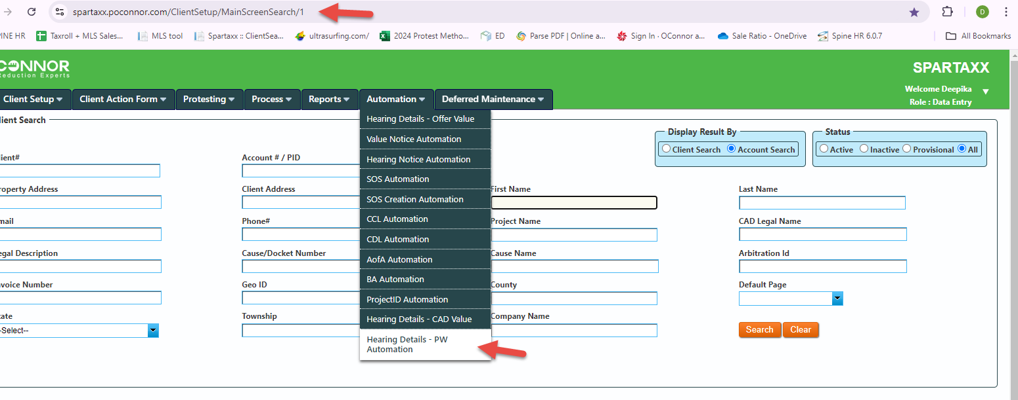

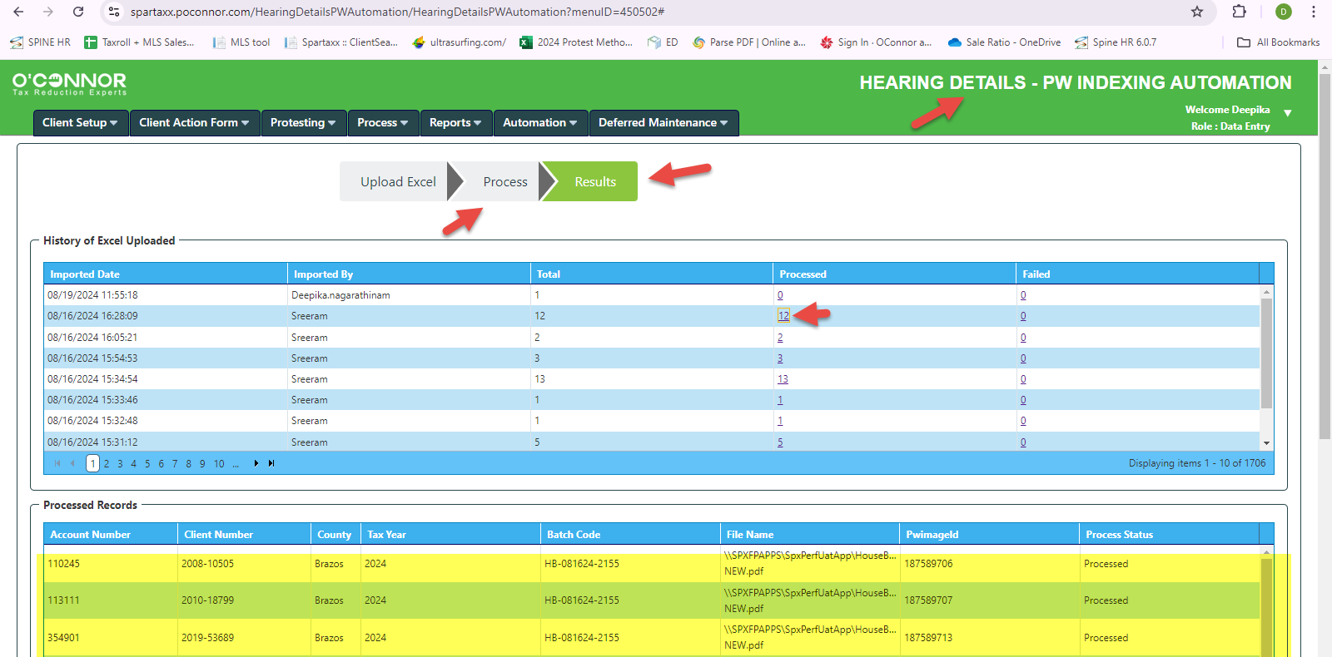
Once the files are uploaded into Spartaxx, it will be available in Paperwise.
(using Elastic Server)

House Bill Value Extraction
Once Housebills are indexed, we need to update the Evidence Letter Date, Scan Date, U & E Values and Mean & Median Values in Spartaxx Hearing Details Tab.
Login SpartaxxAutomation Hearing Details – CAD Values.
The User can find a template for uploading. We can download the template and have the data filled in it.
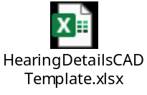
Select the files to be uploaded Click Upload.
The files will be listed out in Spartaxx then Click Proceed.
The Values will be updated in respective field in Hearing Details Tab.
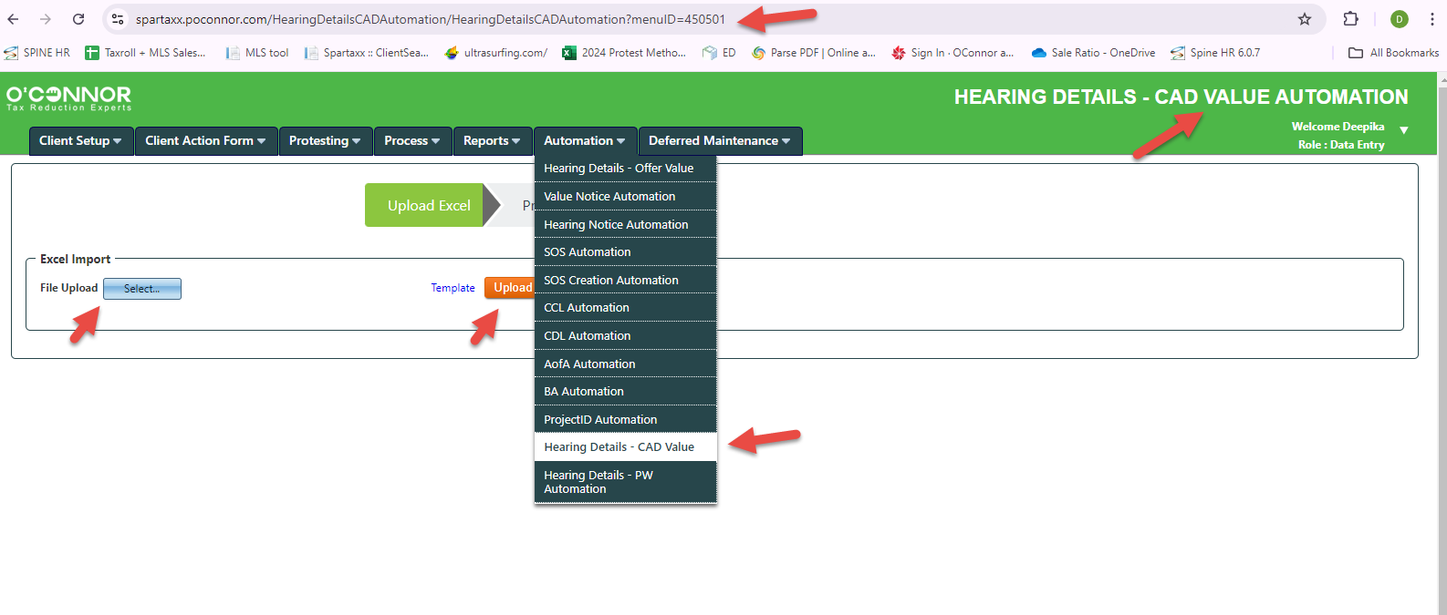

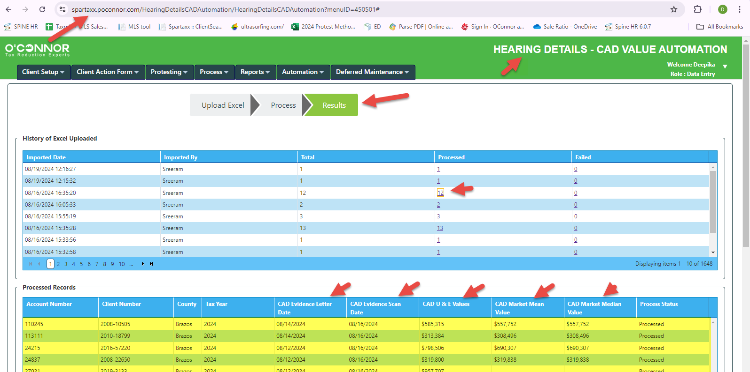

CAD Evidence Letter Date
- It will be available on the House bill Card Page as Printed Date or if the date is not available in card page, we can take the date available in equity or Sales Page on the header.
Note: If the document is sealed, then we need to give preference to the date printed on the seal.

- If none of the above said dates are available, then we can use the current date on which the HB is indexed.

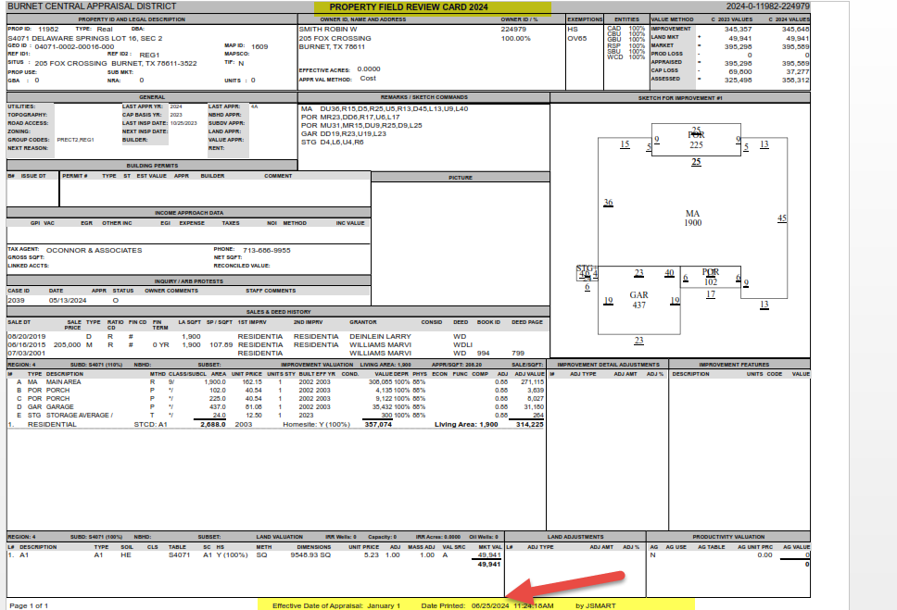

CAD U & E Values
U & E Values are also called Median Equity Value which is available on Equity Page.
We need to take the Subject Property’s Median Equity Value.

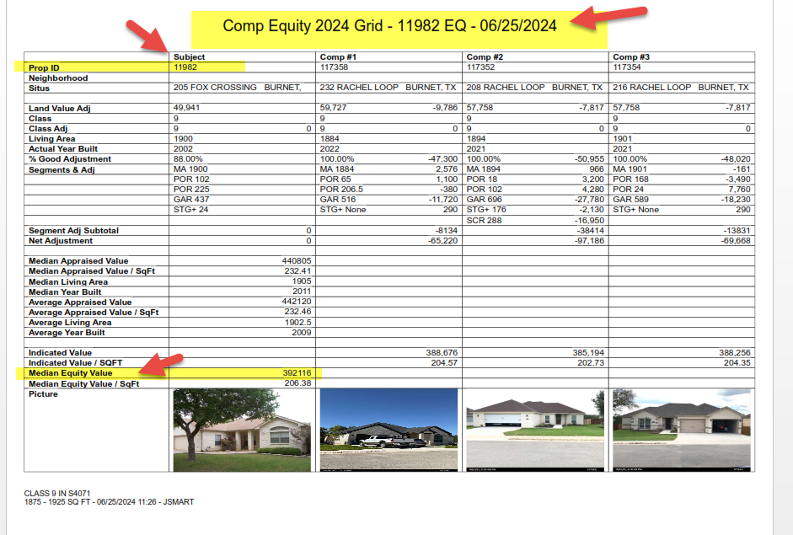

CAD Market Median and Mean Value
Mean & Median Values are available on the Sales Page.
We need to take the Subject Property’s Mean & Median Values.
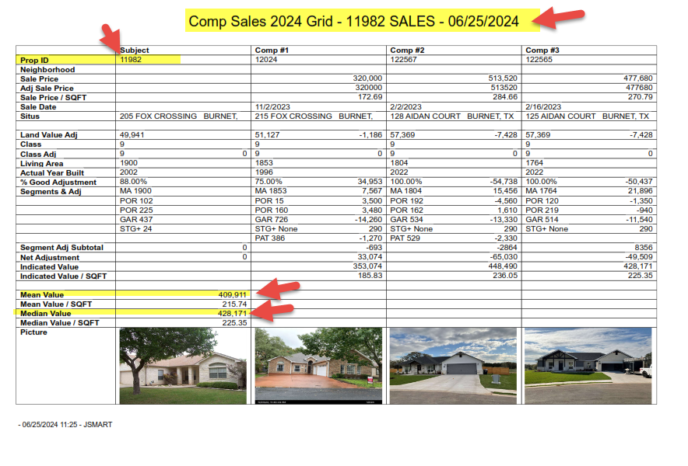
CAD Evidence Scan Date
The Date on which Housebills are scanned into paperwise is called as Evidence Scan.
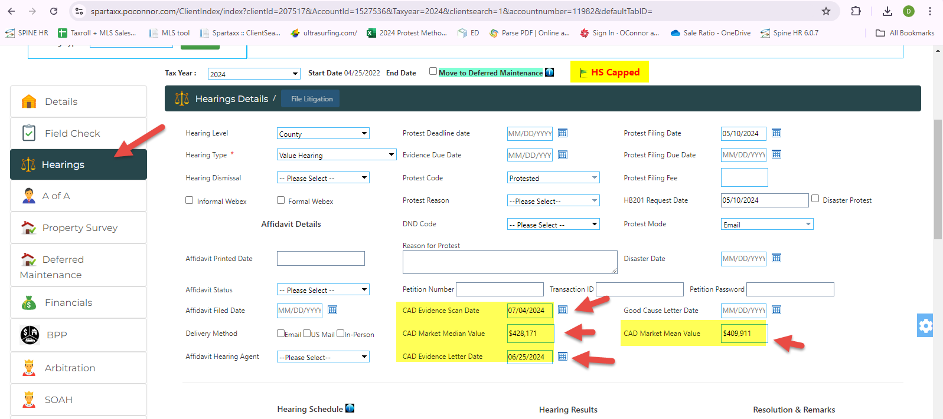

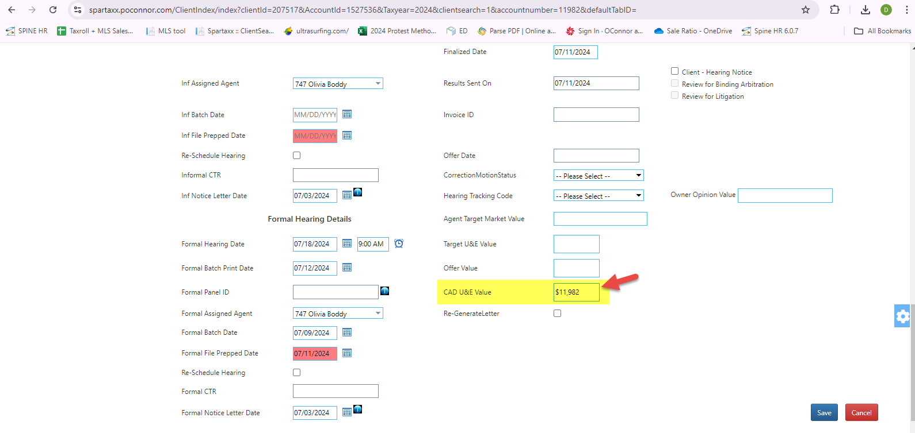

Sales Uploads.
- We have comparable sales on the House bills Sales Pages.
- We need to scrape the Property Id (account number), Sale Date and Sale Price from Sales Comparable.
- We have separate template for uploading the House bill sales.
- We need to Upload the house bill sales by using HB Extractor application.
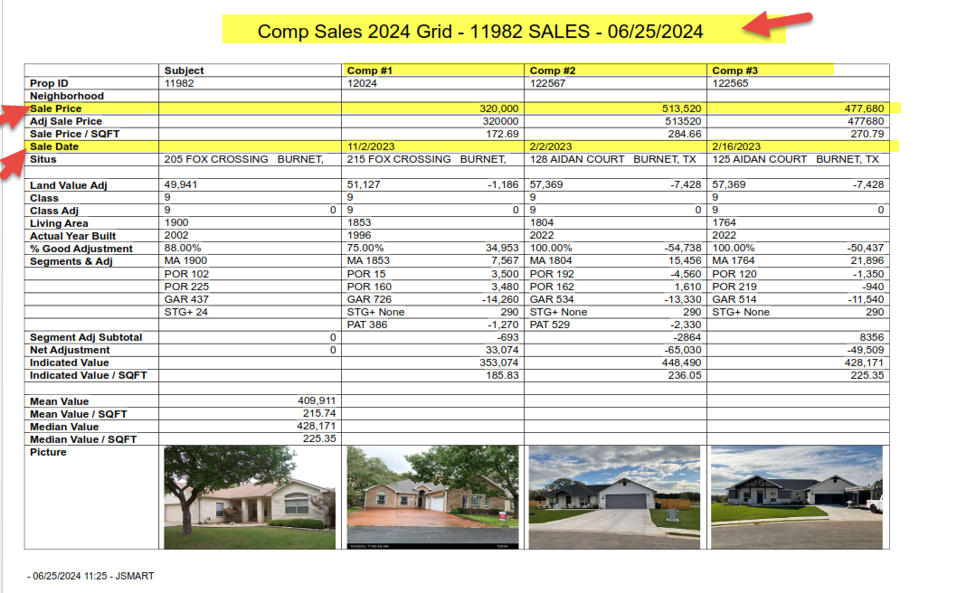

HB Extractor Application.
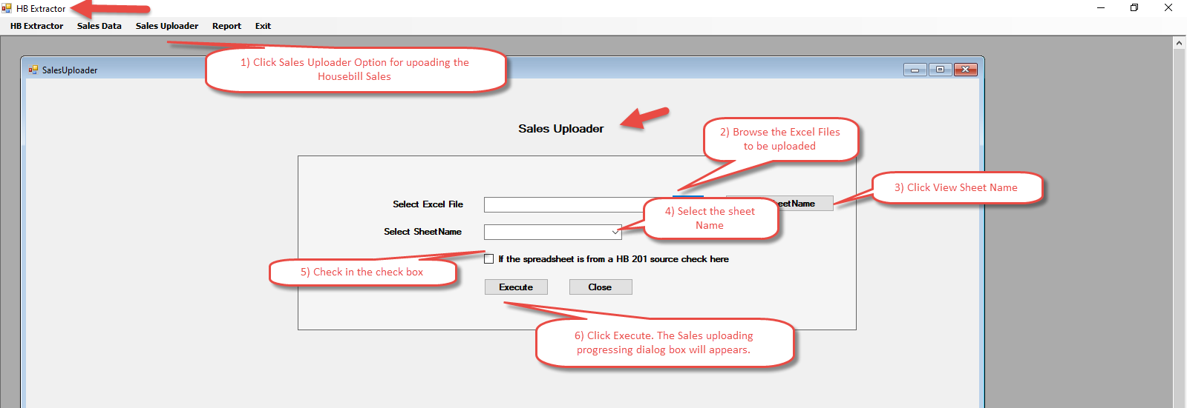
HB Extractor Template:
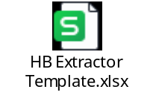
Finally, these sales will be pushed into our sales database.

